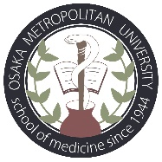 LETTER OF AGREEMENT

Participating international student from will not be charged any tuition, application and program fees by Osaka Metropolitan University.
If Osaka Metropolitan University students participate the exchange program in ,
they will also not be charged any tuition, application and program fees by .

The present agreement is done in 2 original copies in English.

Osaka Metropolitan University

Prof. Norifumi Kawada Prof.
Dean Dean
Graduate School of Medicine and School of Medicine

Date Date

